**The Lord’s Day, December 26, 2021**

Morning Worship Service: 11:00 AM

Sunday School: 10:00 AM

Prelude Musicians

Call to Worship

Lighting the Altar Candles Acolyte

Invocation

Welcome/Recognition of First Time Visitors

Special Music Adult Choir

Kidz Corner Mrs. Olivia

Hymn *“We Three Kings” Hymn #166*

***Offertory***

*Offertory Prayer*

*Receiving Tithes and Offerings*  Ushers

Doxology

Intercessory Prayer

Special Music Taylor Glover

Message Bro. Caleb Hines

Invitational *“Just As I Am” Hymn # 342*

Postlude Musicians

***No Evening Service***

**2021: “Year of Renewed Vision”**

**(Psalm 51:10)**

For announcements and upcoming events, please note the bulletin and screens at the front of the sanctuary!

***Church Family Prayer Concerns***

 *Doris Andrews, Our Pastor & his family, Jackie Flowers, Ben Raposa, Mark Peters, Joe Carter, Ray & Civil Glover, Brenda Wooten, Janie Wilson,* ***Jane Rouse,*** *Dorothy Bass,* ***Nelson Pate,*** *Kathryn Hales, Maxine Parnell,* ***Bessie Tyndall****,* ***Al Alford****,* ***Ashley Alford****, Morris Carter, Debbie Powell, Frances Barnes,* ***Jerry Starnes,*** *Edna Fields, Jean Pierce, Chase & Gracie Parsons, Austin McGinnis, Gerald Ballance, Margaret Newcomb,* ***Kenneth Gardner****, Ava Hare, Connie Mercer, Sue Williams,* ***Carolyn Stanford****, Kenneth Raper Joyce Baker, Kenneth Edwards, Deana Garrou, Miley Shirley, Susan Corbett, Myrna Jones, Robert Watson, Frankie Herring, Sandra Pliescott, Joan Allen, Beverly Wright, Kelly Hamm, Christie Michalek, Brenda Hooks, Ray Bass, Thomas Parnell, Allen and Kirsten Thomas in the loss of Allen’s father Bruce Thomas*

***God’s Servants***

Acolyte Today: Peyton Grantham

Next Week: Grayson Rupert

Counters Today: Fred Rouse and Austin Terrell

Next Week: Todd Wright and Tony Baker

Nursery Today: Nursery is open

Next Week: Nursery is open

Toddler Nursery Today: Jordan Wright and Jaimie Mitchell

Next Week Trudi Rast and Paige Renfrow

Children’s Church: Kaitlyn Lewis and Katie Stallings

Next Week: Martha Herndon and Mary Gardner

Youth Church: Tabby Davis

Next Week: Olivia Stallings

Greeters: Charlene Pate

Next Week: Kathryne Parnell

Prayer Partners: Fred and Jane Rouse

Next Week: Phyllis Bass and Debbie Hare

***Opportunities to Fellowship This Week***

**Today:** 10:00 A.M. Sunday School

11:00 A.M. Morning Worship Service

2:30 P.M. “Pleasant News” TV Program

**Monday:** 10:00 P.M. “Pleasant News” TV Program

**Wednesday:** 6:30-8:30 P.M. Floating Prayer Service

**Announcements and Upcoming Events**

**DEACON OF THE WEEK: Dee Sasser: 919-252-0887.**



**This Wednesday night from 6:30 until 8:30 PM, we will have a floating prayer service as we pray for God’s blessings on the New Year! Come and pray over our Sanctuary as we prepare for 2022!**

**Our Ladies’ Events Team is planning a weekend retreat at Cragmont for all women of our church that might be interested. The tenative dates would be Friday March 18th thru Sunday March 20th. The accomodations would be in the newer Lodge on the campus of Cragmont (Black Mountain, NC). The cost of the room will depend on how many share a room. The rooms can accommodate up to four per room. The total cost of the room per night is $80.00, so for 2 nights with 4 in a room, total lodging cost would be $40 per person It would be a weekend of devotions, discussions, sightseeing and just having a time of getting to know each other and kinship with other Christian ladies. We do not have an exact cost (this will depend on how many ladies participate, but our goal is to keep the costs at a minimum. The cost would include lodging, a t-shirt and a gift bag. Each lady would be responsible for the cost of their meals and any excursions that might include a fee (but we would certainly try to keep this to a minimum). There is a signup sheet in the hallway and we know that this will be a refreshing and renewing weekend. If you have any questions, please see Michelle Hamm,, Tracy Pittman, Marsha Sauls, Katie Stallings or Kathryne Parnell or Charlene Pate.**

**We are in need of Prayer Partners to pray during the worship service each Sunday Morning. You would only be scheduled no more than one Sunday each month, and if we could get enough volunteers, less often. This is an important part of our worship service and you would retire to the prayer room following the Pastor receiving prayer requests. If you are interested in serving in this capacity, please see Debbie Hare, Joan Allen or Kathryne Parnell and we thank you in advance for your service.**

**Congratulations to Kristen Sauls on her graduation from Wayne School of Engineering, but also with an AA degree from Wayne Community College. Kristen will begin the Spring Semester at ECU in the next few days!**



*The Beautiful Flowers that grace our altar today are for the Glory of the Lord!*

***This Week’s Birthdays***

December 30th Kristen Sauls

***This Week’s Anniversaries***

No Anniversaries this week

***Last Week’s Offerings & Attendance***

*Tithes &Offerings for December 19th : $4,357.85*

*Morning Service Attendance: 147*

**Hospital:**

**Our Home Bound Members:**

Doris Andrews

Robert Watson

Edna Fields: 4513 Fieldstone Circle, Southport, NC 28461

Frances Barnes: c/o Fran Barnes-Melvin

8206 Stonetown Ave., Raleigh, NC 27612

Margaret Nerwcomb: with daughter Tracey @ 137 Rowe St., Goldsboro, NC 27530

**Nursing Homes & Assisted Living:**

Nelson Pate Willow Creek - Goldsboro

**Deacons Trustees**

Dee Sasser James Kirby

Jeremy Ellsworth Bob Howett

Steve Vail Matt Rast

Morris Pate-Chairman Jon Oakes- Chairman

Terry Aycock

Tommy Herndon-Co-Chairman

Stan Stanford

**2021 Youth Team WRPG Radio Commission**

Tracy Pittman-Chair Jeremy Ellsworth-Chairman

Karen Terrell Kathryne Parnell

Tabby Davis Debbie Hare

Lauren Crawford Ronnie Barnes

Trudi Rast Walter Fleming

Bob Howett, Station Mgr.

**WELCOME FIRST TIME GUESTS!**

We’re glad you’re here. Thank you so much for coming today. Whether you are a growing believer or simply checking out the truths of Christ, we hope that you experience a fresh expression of God while you are here today. Just sit back…relax, and let yourself be touched by God’s spirit. We want your visit with our family to be a special one.

***Pleasant Grove Original Free***

***Will Baptist Church, Inc.***

*“A Going Church for a Coming Lord”*

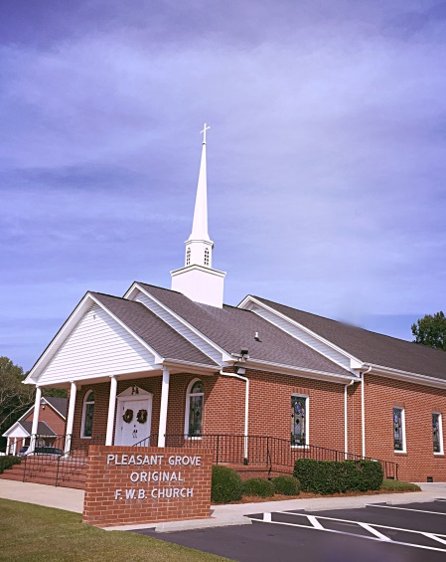

***December 26, 2021***

***Rev. Franklin G. “Barry” Stallings, Pastor***

***Mobile: (919) 738-0108***

[***pastorbub@nc.rr.com***](mailto:pastorbub@nc.rr.com)

***Caleb Hines, Director of Youth Services***

***Mobile: (252) 675-5544***

***chinespgym@gmail.com***

***Church Office: (919) 242-6802***

***WRPG Radio Studio: (919) 242-6820***

*To all who mourn and need comfort, to all are friendless and need friendship, to all who are homeless and need sheltering love, to all who pray and to all who do not, but should, to all who sin and need a Savior: this Church opens wide its doors. Come in the spirit of reverence; worship in the spirit of humility; serve in the spirit of victory!*

***P.O. Box 36***

***Pikeville, NC 27863***

[***www.pleasantgroveofwbchurch.org***](http://www.pleasantgroveofwbchurch.org)